Delivery update
August 2026

Holmview station precinct
Updated design
The Logan and Gold Coast Faster Rail (LGC) project, funded by the Australian and Queensland governments, is delivering a new Holmview station precinct to improve safety, accessibility, and local road connections associated with the removal of the Spanns Road and Holmview Road level crossings.
Updates to the design include:
- the current cattle siding facility will be extended at its current level, enabling the re-use of the existing platform. This extension will allow a full cattle train to be unloaded without affecting passenger trains on the main line
- a new road connection will link Thorsborne Street to Spanns Road parallel with the rail corridor, providing a local access alternative, including during flood events
- the intersection of Chapman Drive and Boundary Street will be upgraded to include traffic signals.

Level crossing removals
The level crossings at Spanns Road and Holmview Road in Beenleigh will be closed.

Spanns Road
- The southern side will be converted to a cul-de-sac.
- A new pedestrian overpass will provide improved access to both sides of the rail corridor.

Holmview Road
- A new road connection will link Holmview Road to Chapman Drive to maintain local access.
- A new pedestrian and cycling connection will provide access over the rail corridor in the vicinity of Houdini Terrace.
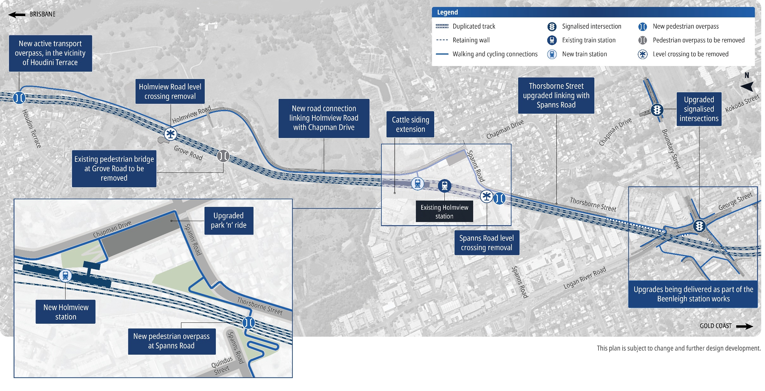

How community feedback shaped the updated design
Community feedback from design engagement undertaken in 2023 has been incorporated into the updated design for the Holmview station precinct, to further improve accessibility, safety and customer experience.

What you told us
- Strong feedback received around the station location and flood prone areas.
- Local access changes associated with the level crossing closures at Holmview Road and Spanns Road are required, including during flood events.
- Station location to consider improved connectivity and accessibility.

What we are doing
- Relocating the station to improve flood resilience and ensure greater reliability of future services.
- Building a new road linking Holmview Road to Chapman Drive, and another linking Spanns Road to Thorsborne Street to improve local connectivity.
- The park ‘n’ ride will increase to more than 50 car spaces.
- Traffic signals will improve local traffic flows at Boundary Street and Chapman Drive, and Boundary Street, George Street and Logan River Road intersections.
- A pedestrian overpass at Spanns Road and an active transport overpass north of Holmview Road near Houdini Terrace will improve station access.

Community drop-in sessions
You can speak directly with the project team at one of the following sessions:

Beenleigh Mall
40 Main Street, Beenleigh
Thursday 10 September 2026
9am-12pm and 3pm-6pm

Logan Lightning Football Club
33/35 Boundary Street, Beenleigh
Saturday 12 September 2026
9am-12pm

Beenleigh Library
18-20 Crete Street, Beenleigh
Wednesday 16 September 2026
9am-12pm
Online: www.yoursay-projects.tmr.qld.gov.au/logan-and-gold-coast-faster-rail
Deadline: Submit your feedback by Monday 5 October 2026.

Next steps for the project
The LGC Rail package is being delivered by the ActivUs Alliance, made up of the Department of Transport and Main Roads, Queensland Rail and ActivUs.
The project includes:
- doubling tracks between Kuraby and Beenleigh from two to four
- removing level crossings to improve safety
- improved access and connectivity along the 20km project corridor
- modern station upgrades.
Design finalisation and site establishment works are underway, with major construction expected to begin across the corridor later in 2026.

Stay up to date
Search on tmr.qld.gov.au: ‘Logan and Gold Coast Faster Rail’
Email: lgcrail@activusalliance.com.au
Call: 1800 957 066 (all hours)
For further information, or if you require translation or support services to access
the documentation, please contact the project team on 1800 957 066 (9am – 5pm Monday to Friday).
For more information, visit www.yoursay-projects.tmr.qld.gov.au/logan-and-gold-coast-faster-rail

13 QGOV (137468)
www.tmr.qld.gov.au | www.qld.gov.au

