Works notice
November 2026

Loganlea Station Relocation project

What's happening?
From 1 – 30 November 2026, works will include:
Valencia Street, station precinct and platform 1:
- Installing platform finishes, fit-out, fencing and furniture
- Electrical fit-off
- Pre-assembling footbridge structural steel
- Precinct and car park landscaping, including installing trees
- Potholing and services location.
Rail corridor and platform 2 (Armstrong Road-side):
- Bulk excavation
- Scaffolding
- Drainage works
- Concrete pours and associated works
- Capping and installing subgrade
- Installing precast panels
- Constructing lift shafts.
Armstrong Road:
- Retaining wall backfilling
- Road barrier realignment.

Work hours
Standard hours: 6.30am to 6.30pm, Monday to Saturday
Out of hours: 6.30pm to 6.30am, Monday to Sunday
Weather and site conditions permitting.

Armstrong Road temporary bus stop relocation
To facilitate the station construction works on Armstrong Road:
- From Tuesday 3 November 2026, bus stop 321110 (closest to Logan Hospital) will be temporarily closed at this location and relocated to Armstrong Place, Meadowbrook, next to the basketball court, until mid-2027 (see map below).
- Please follow signage and traffic controller directions to the new location.
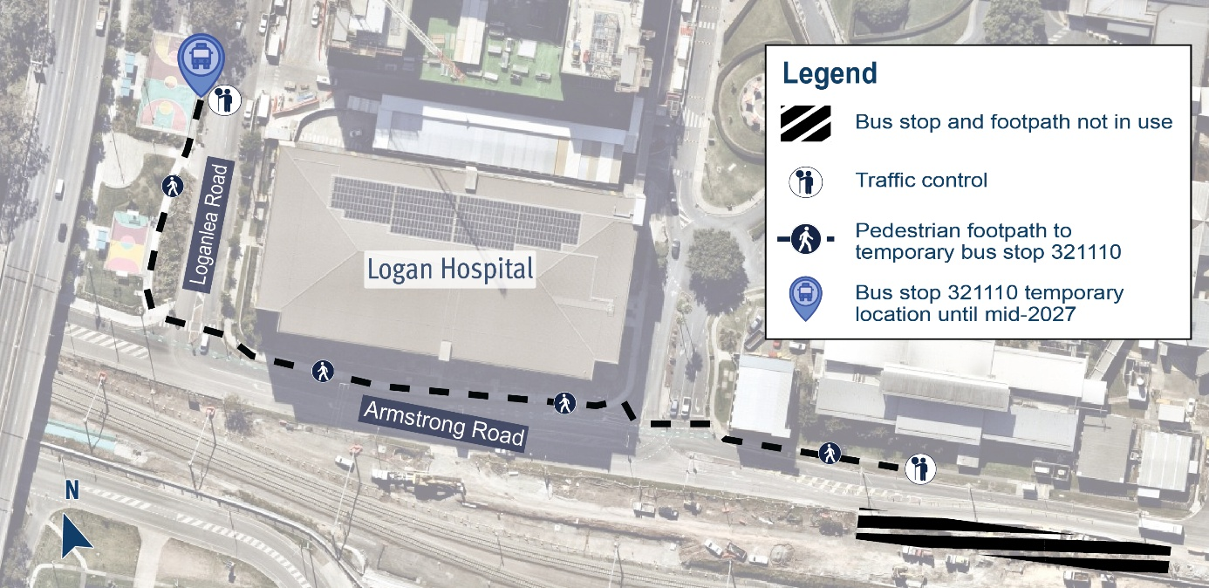

Out of hours works
During November, some activities will be undertaken outside standard work hours, to:
- relocate bus stop 321110 (closest to Logan Hospital) and realign road barriers on Armstrong Road.
Rail corridor (Armstrong Road-side) and platform 2 works:
- retaining wall backfilling
- installing precast panels
- bulk excavation and capping placement
- concrete pours and associated works.
Work will be undertaken intermittently during the day and at night, up to seven days a week. Where possible, work will be prioritised to occur between 6.30am to 6.30pm; some activities may occur throughout the night until 6.30am.
We appreciate your patience during these works. We will continue to keep you updated as works progress.

What to expect
- Some noise, dust and vibration
- Water trucks and road sweepers to suppress dust
- Vehicles and equipment with flashing lights and reversing beepers
- Lighting towers (directed away from residences, wherever possible)
- Changed traffic conditions including temporary road closures and reduced speed limits.

Temporary traffic and pedestrian changes
Armstrong Road
- Intermittent lane closures and traffic holds to facilitate deliveries.
- Bus stops will remain open (ID: 321110 and 310669).
Edenlea Drive
- Truck haulage route until the Loganlea Station Relocation project is completed in 2027.
- Some night movements may be necessary and will be minimised where possible.

Project work areas
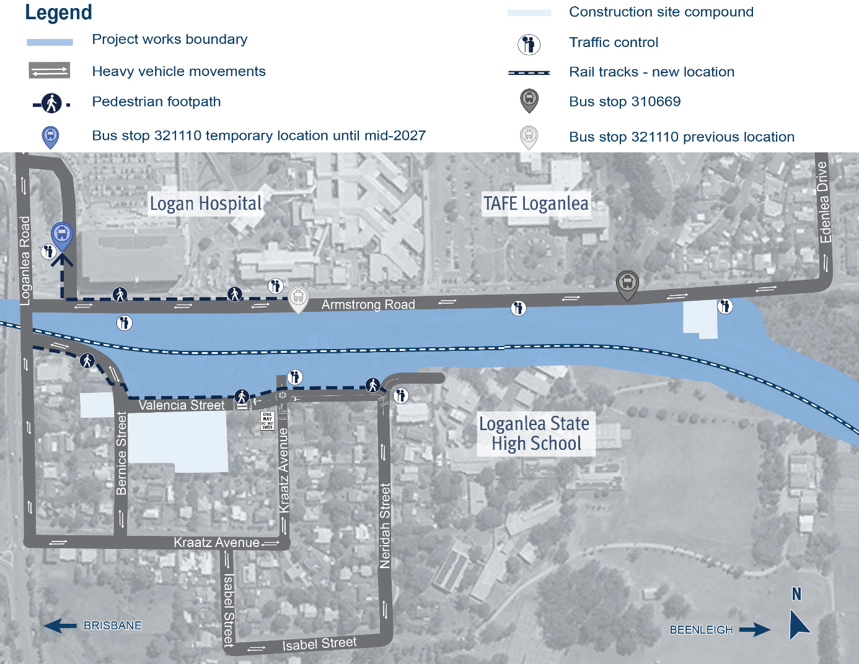

Loganlea rail corridor works
During November 2026, rail corridor works will be happening outside the Loganlea Station Relocation project area, between Railway Parade to Logan River, Loganlea, for the Logan and Gold Coast Faster Rail project.
For more information visit: www.tmr.qld.gov.au/logangoldcoastrail.

About the project
The new Loganlea station will be located 500m to the south, opposite the Logan Hospital and closer to other health, education and community services.
During construction, the existing Loganlea station remains open.
The LSR project is jointly funded by the Australian and Queensland governments.

Stay up to date
Search on tmr.qld.gov.au: ‘Loganlea Station Relocation’
Email: LSR@martinusdegnan.com.au
Call: 1800 957 066

For information in Gagana Sāmoa, ਪੰਜਾਬੀ, 简体中文 and عربي, or other support services, please contact the project team on 1800 957 066 (9am – 5pm Monday to Friday).

www.tmr.qld.gov.au/logangoldcoastrail
13 QGOV (137468)
www.tmr.qld.gov.au | www.qld.gov.au

