Works notice
September 2026

Loganlea Station Relocation project
During September 2026, works will include:

What's happening?
Platform1:
- Installing the lift shaft and platform finishes
- Customer services area fit out.
Valencia Street / station precinct works:
- Valencia Street / Kraatz Avenue: Installing permanent roundabout
- Valencia Street / Bernice Street intersection: Asphalting and pavement works
- Valencia Street: Installing footpath, traffic island and kerbing
- Neridah Street: Kerbing works
- Station building: Installing canopy finishes, internal fit-out works
- Ongoing drainage works
- Line marking works.
Rail corridor (Armstrong Road) works:
- Installing fencing
- Drainage works
- Bulk excavation and piling works
- Concrete pours.

24-hour works
19 September – 5 October 2026
Valencia Street:
- Drainage
- Roadworks, including saw cutting, asphalting and pavement works, and line marking.
Rail corridor (Armstrong Road):
- Large equipment / material deliveries
- Demolition works, including saw cutting
- Bulk excavation works
- Piling works
- Track formation works
- Concrete pours
- Installing roofing.
These works will be undertaken during the planned track closure, to ensure the safety of the construction team / workers.

Temporary traffic and pedestrian changes (24-hour)
19 September – 5 October 2026

Valencia Street:
- Closed to traffic
- Pedestrian access along Valencia Street will switch along the north and south footpaths, as works progress.

Bernice Street:
- Traffic reduced to one lane periodically to allow for:
  - re-asphalting the Valencia Street intersection
  - line marking and removal.
Please follow the direction of traffic controllers, to ensure safety.
Please see Project work areas map over the page.

Armstrong Road
- Bus stops will remain open (ID: 321110 and 310669).
- Intermittent lane closures to facilitate deliveries.

Edenlea Drive
- Truck haulage route until the Loganlea Station Relocation project is completed in 2027.
We appreciate your patience during these works. We will continue to keep you updated as works progress.

Project work areas

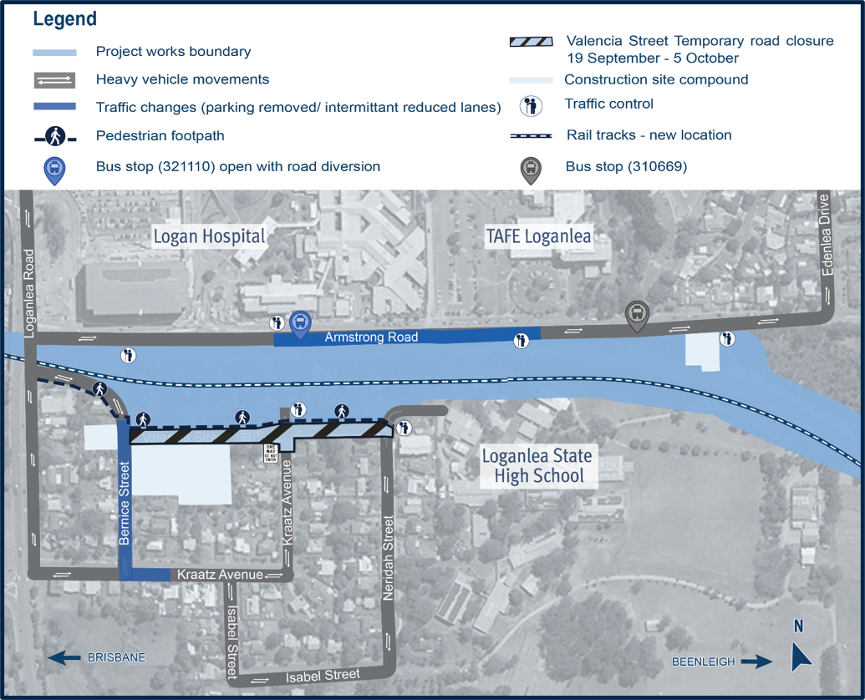

Work hours
Standard hours: 6:30am to 6:30pm, Monday to Saturday
24-hour works: Valencia Street roadworks and rail corridor (Armstrong Road) works
Weather and site conditions permitting.

What to expect
- Some noise, dust and vibration
- Water trucks and road sweepers for dust suppression
- Vehicles and equipment with flashing lights and reversing beepers
- Lighting towers (directed away from residences, wherever possible)
- Changed traffic conditions including temporary road closures and reduced speed limits.

Planned track closures
Between 19 September to 11 October 2026, there will be track closures and travel changes on the Beenleigh and Gold Coast train lines.
Please consider your travel options, plan ahead, and allow extra travel time.
Download the Translink app, visit translink.com.au or call 13 12 30.

Permanent traffic changes – new right-turn lanes
Bernice Street and Kraatz Avenue
From 28 September 2026, there will be permanent traffic changes with new right-turn lanes installed from:
- Bernice Street into Valencia Street
- Kraatz Avenue into Bernice Street.
This is to enable local traffic movements, with Valencia Street becoming one-way only, between Bernice Street and Kraatz Avenue.
Car parking removal: As part of these works, some car parking will be permanently removed along Bernice Street and Kraatz Avenue. Please see map below.
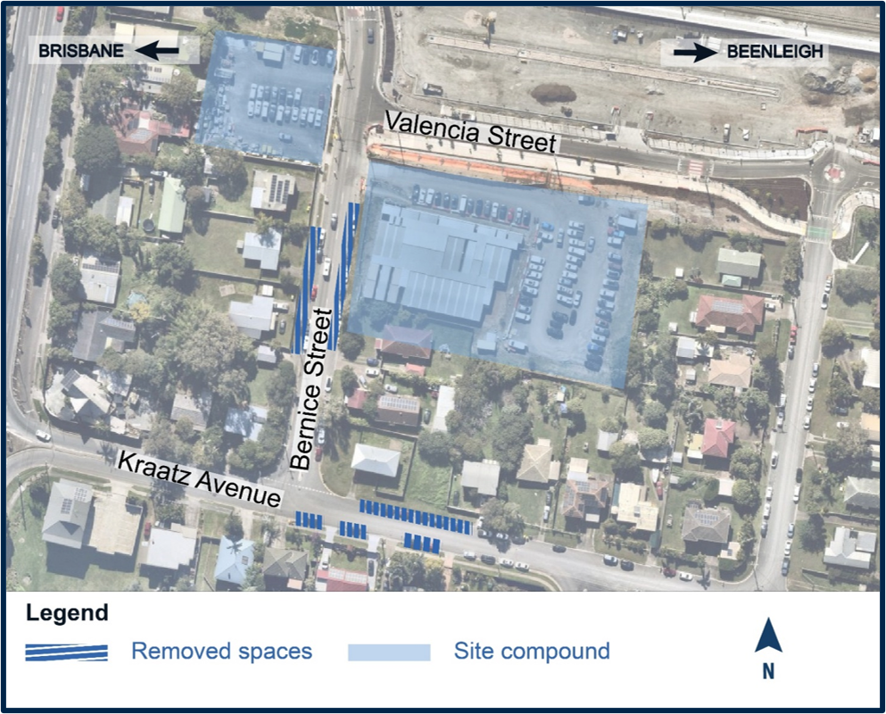
The new Loganlea station will include a new 250-space park ‘n’ ride facility on Valencia Street.
TMR is continuing to investigate options for improved connections to the Loganlea station, including retaining some parking at the existing station and working with stakeholders on opportunities to provide additional car parking in the future.

About the project
The new Loganlea station will be located 500m to the south, opposite the Logan Hospital and closer to other health, education and community services.
During construction, the existing Loganlea station remains open.
The LSR project is jointly funded by the Australian and Queensland governments.

Stay up to date
Search on tmr.qld.gov.au: ‘Loganlea Station Relocation’
Email: LSR@martinusdegnan.com.au
Call: 1800 957 066

For information in Gagana Sāmoa, ਪੰਜਾਬੀ, 简体中文 and عربي, or other support services, please contact the project team on 1800 957 066 (9am – 5pm Monday to Friday).

www.tmr.qld.gov.au/logangoldcoastrail
13 QGOV (137468)
www.tmr.qld.gov.au | www.qld.gov.au

