Project update
September 2026

Loganlea Station Relocation project
Relocating and upgrading Loganlea station to better connect customers with nearby health, education, and community services.
Key benefits for the community
- Improved safety
- Increased accessibility
- Improved network efficiency
- Better connections to nearby services

New tracks mark major milestone
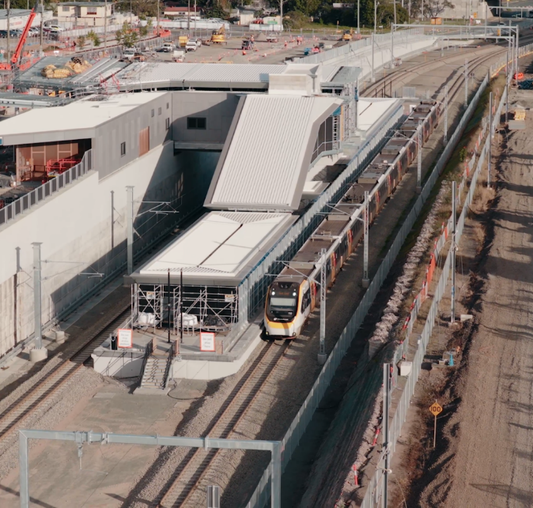
The Loganlea Station Relocation (LSR) project reached a major milestone this quarter, with train services successfully switching from the old tracks to the two newly built tracks at Loganlea.
Image: Trains running on the new alignment
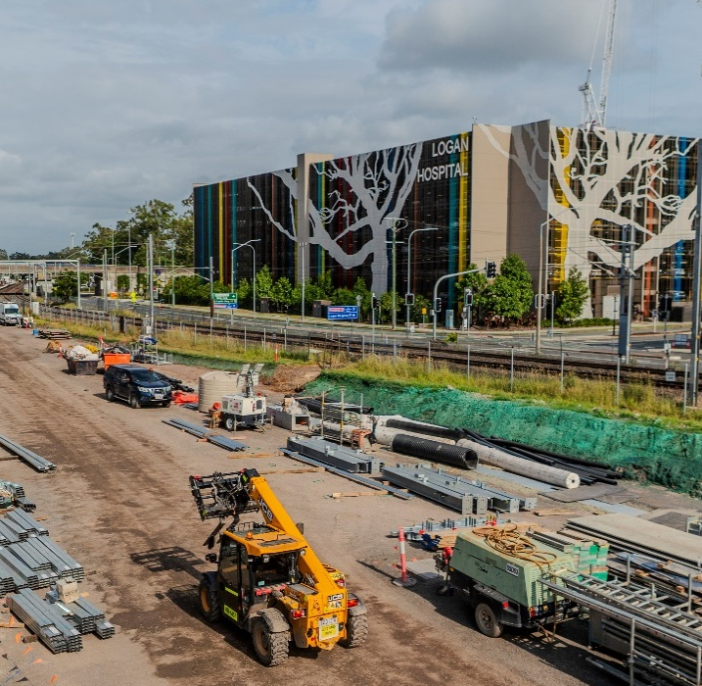
Image: New track formation works – Valencia Street

Construction of the new tracks was carried out, with the existing Loganlea station remaining open as a key transport interchange.
The new rail alignment through the new station precinct will help deliver future rail network efficiency and reliability improvements.
The works included decommissioning the old tracks.
The successful transition from an active construction site to a safe and reliable rail corridor required strong collaboration across the project partners.
We would like to thank the community for your patience during these works.
In addition, work:
- on the station platform and building on Valencia Street is nearing completion
- has commenced on the structures for the second platform, on the Armstrong Road side.

Planned works – September to December 2026
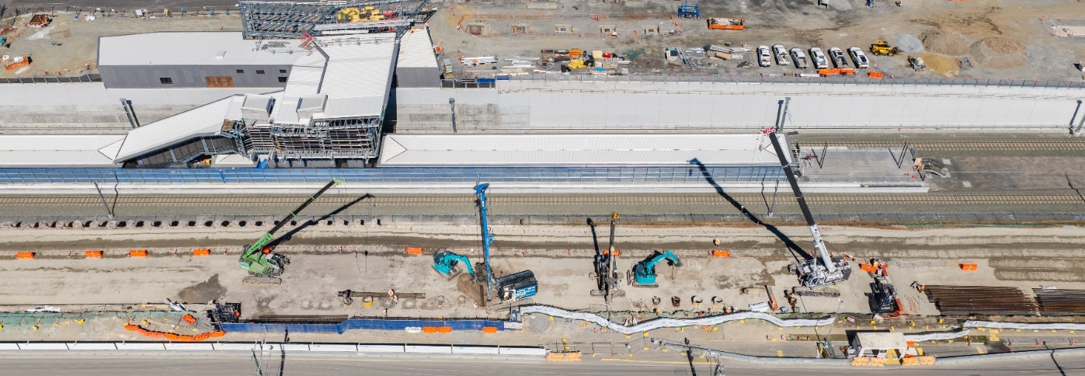
Image: Northern retaining wall piling – Armstrong Road

Platform 2 Armstrong Road
- Bulk excavation, demolition and piling for the second platform.
- Coordination with nearby construction projects to minimise community impact.
Valencia Street
- Roadworks to complete drainage, asphalt, kerbing and remedial works.
- Line marking and construction of the permanent roundabout at the Kraatz Avenue junction.
- Valencia Street will be closed for works during the September school holidays.
Station building
- Internal fit-out, canopy finishes and drainage.
Platform 1
- Final works on platform one such as lift shaft including: signage, furniture and fit out of the customer services area.

Sustainability
The LSR site compound is proudly powered by 100% renewable energy!
June 2026
We had avoided 150 tonnes CO2-E (Carbon Dioxide Equivalent) which equates to:
- 23 return flights from Sydney to London
- 14 Australian households’ annual electricity consumption.
Sept 2026
We have now avoided 242 tonnes CO2-E (Carbon Dioxide Equivalent) which equates to:
- 37 return flights from Sydney to London
- 23 Australian households’ annual electricity consumption.

Successful work experience program
Congratulations to four Loganlea State High School students for completing a five-week work experience program with the Loganlea Station Relocation project.
They gained an exclusive behind-the-scenes look at disciplines such as project administration, workplace health and safety, environment, civil construction, structures and communications.
The program included supervised site activities, team engagement, project-based tasks, and reflection activities, giving students a valuable insight into the wide range of careers that contribute to major infrastructure projects.
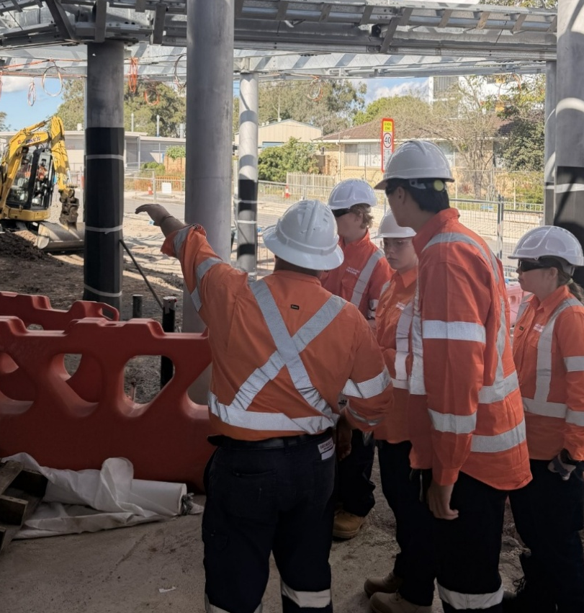
Image: LSHS students completing work experience on site

Progress to date
- Trains running on the two new tracks.
- Old tracks decommissioned.
- Platform 1 station building on Valencia Street nearing completion.
- Platform 2 (Armstrong Road-side) works commenced.
- First section of the new pedestrian footbridge installed.
- Valencia Street roadworks nearing completion with pedestrians and cars already able to start accessing the area.
- New park ’n’ ride facilities on Valencia Street are taking shape.

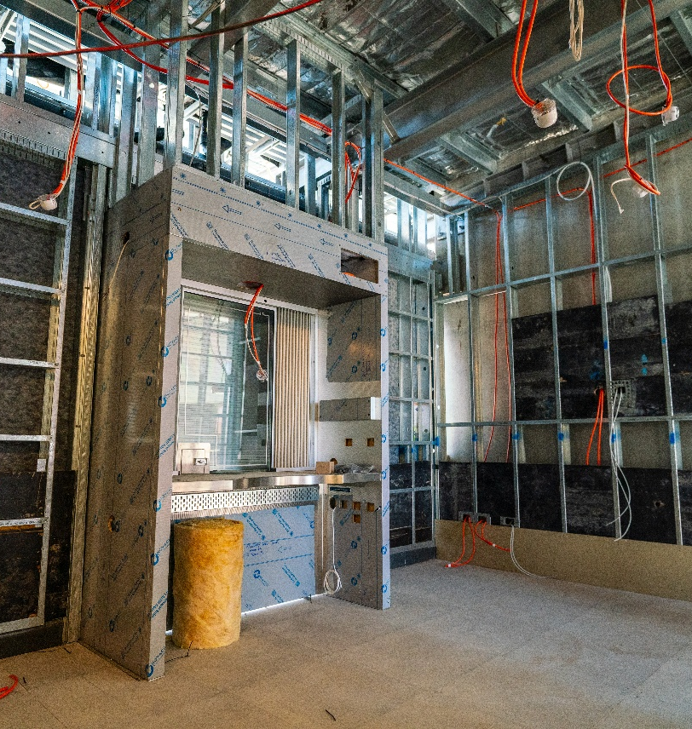
Image: New ticket window installed – station building
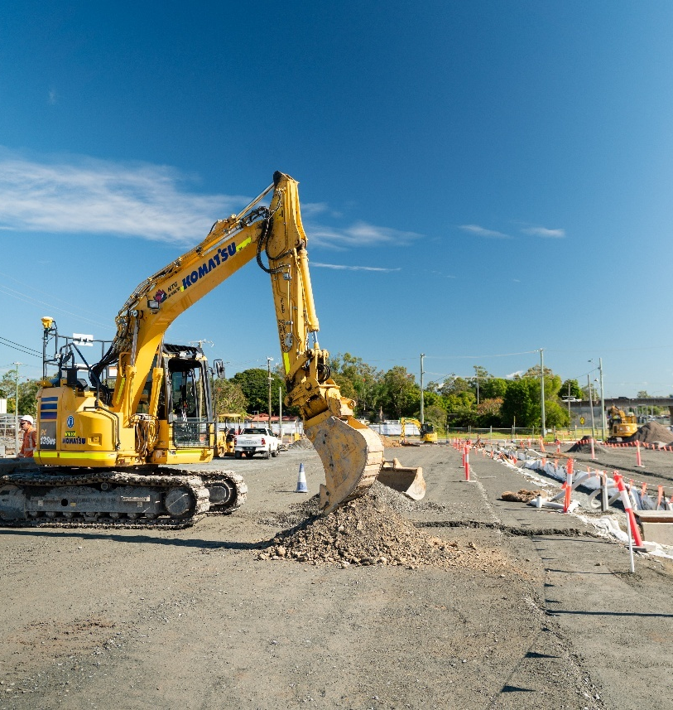
Image: New car park construction – Valencia Street

Community sentiment survey results
What you told us…
Thank you to the community members who participated in our recent sentiment survey.
We received 162 responses over the five weeks the survey was open in June / July this year.
The feedback showed an overall positive community sentiment and awareness about the LSR project. This tells us our communication channels are working. We will continue to monitor and look for ways to improve our communication efforts, as works progress.
There was also strong interest in parking at the new station. The Department of Transport and Main Roads is continuing to investigate opportunities to provide additional car parking in the future.
Improved bus services to Loganlea station have recently been introduced, making it easier for customers to access rail services now and in the future when the new station has been completed.

Project overview
The LSR project will improve accessibility and safety at the new station, with dual lifts on each platform, an elevated pedestrian connection over the rail line, conveniently located bus stops, kiss ‘n’ ride and park ‘n’ ride facilities, and better lighting and security features.
The existing station will remain open to customers while the new station is being built 500m to the south, opposite Logan Hospital. The Australian and Queensland governments have jointly committed $173.8 million to deliver the project.
Loganlea station is located within the Logan and Gold Coast Faster Rail project corridor, a $5.75 billion project jointly funded by the Australian and Queensland governments.
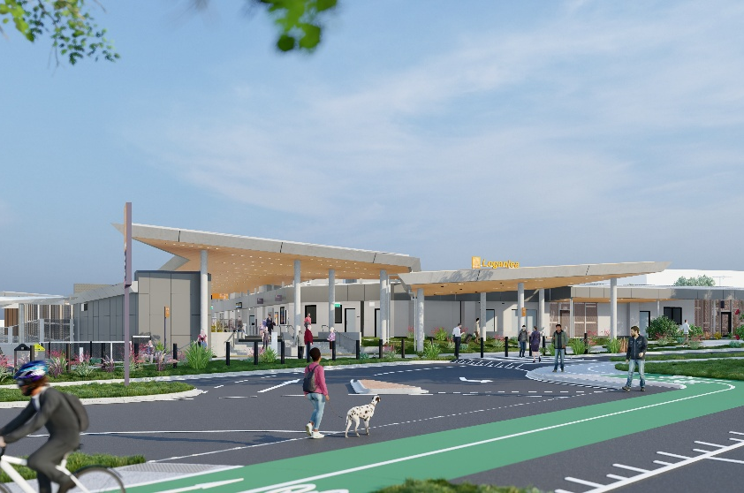
Image: Artist impression of station building – Valencia Street

Stay up to date
Search on tmr.qld.gov.au: ‘Loganlea Station Relocation’
Email: LSR@martinusdegnan.com.au
Call: 1800 957 066
For information in Gagana Sāmoa, ਪੰਜਾਬੀ, 简体中文 and عربي, or other support services, please contact the project team on 1800 957 066 (9am – 5pm Monday to Friday).

www.tmr.qld.gov.au/logangoldcoastrail
13 QGOV (137468)
www.tmr.qld.gov.au | www.qld.gov.au

