Works notice
Late August – September 2026

Loganlea Station Relocation project
Nightworks
Between 24 August – 30 September 2026, the following activities will be conducted outside of standard working hours:

What's happening?
Rail corridor (Armstrong Road) works:
- Installing fencing
- Drainage works
- Bulk excavation and piling works
- Concrete pours.
Valencia Street:
- Installing asphalt
- Line marking.

Please see map over the page
We appreciate your patience during these works. We will continue to keep you updated as works progress.

Work hours
Out of hours: 6:30pm to 6:30am, Monday to Saturday
Weather and site conditions permitting.

Project work areas

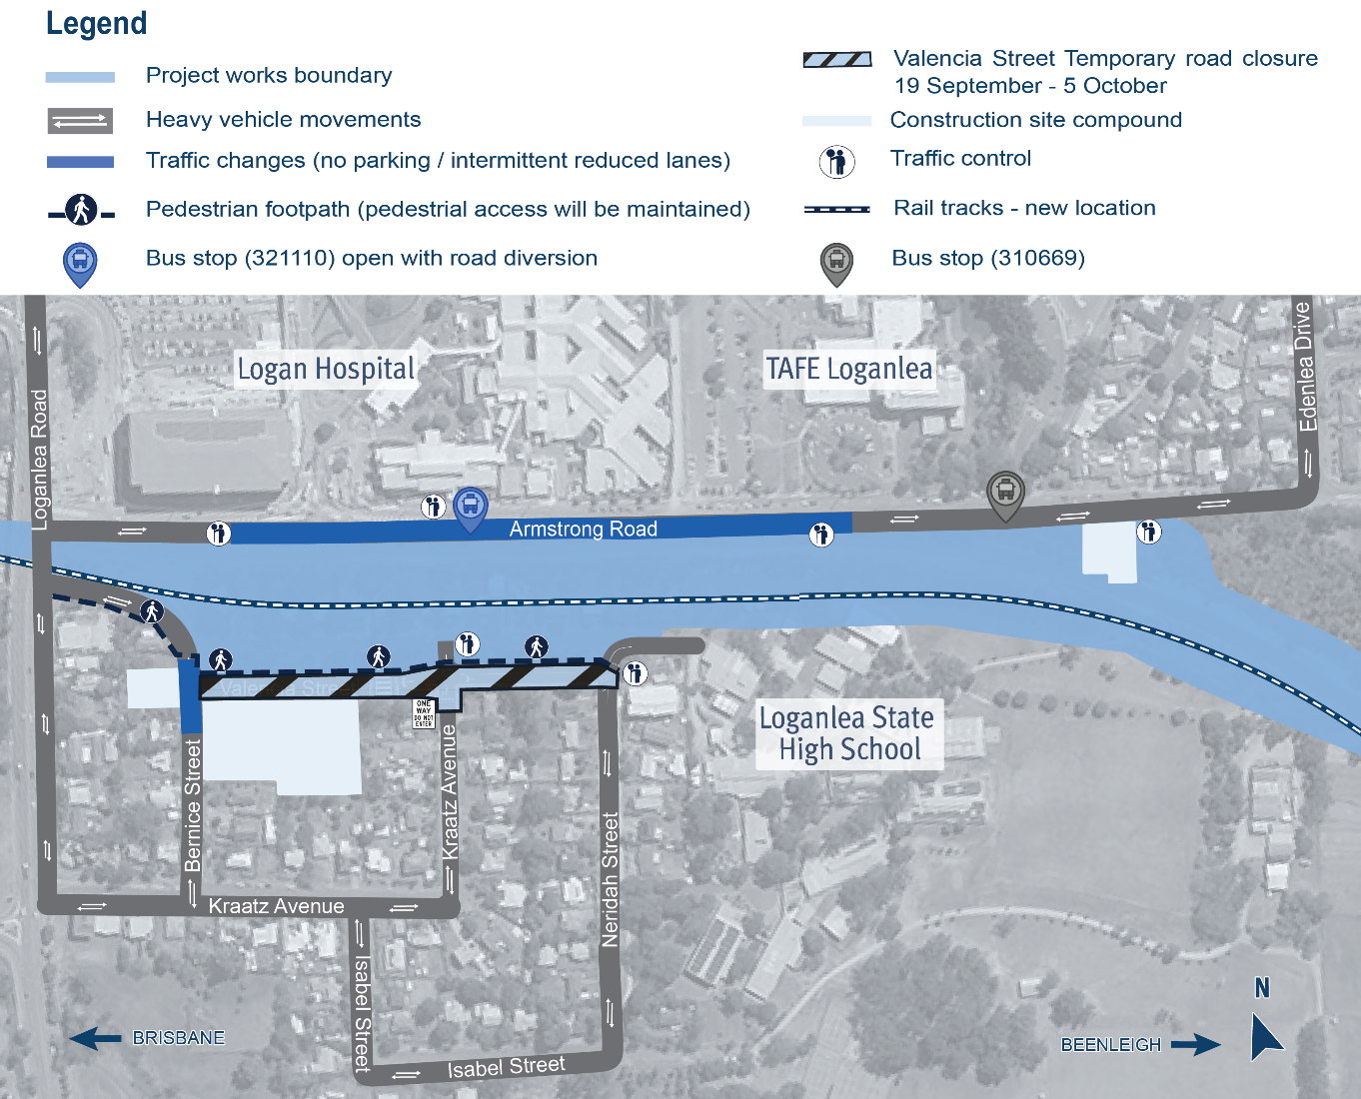
About the project
The new Loganlea station will be located 500m to the south, opposite the Logan Hospital and closer to other health, education and community services.
During construction, the existing Loganlea station remains open.
The LSR project is jointly funded by the Australian and Queensland governments.

Stay up to date
Search on tmr.qld.gov.au: ‘Loganlea Station Relocation’
Email: LSR@martinusdegnan.com.au
Call: 1800 957 066

For information in Gagana Sāmoa, ਪੰਜਾਬੀ, 简体中文 and عربي, or other support services, please contact the project team on 1800 957 066 (9am – 5pm Monday to Friday).

www.tmr.qld.gov.au/logangoldcoastrail
13 QGOV (137468)
www.tmr.qld.gov.au | www.qld.gov.au

