


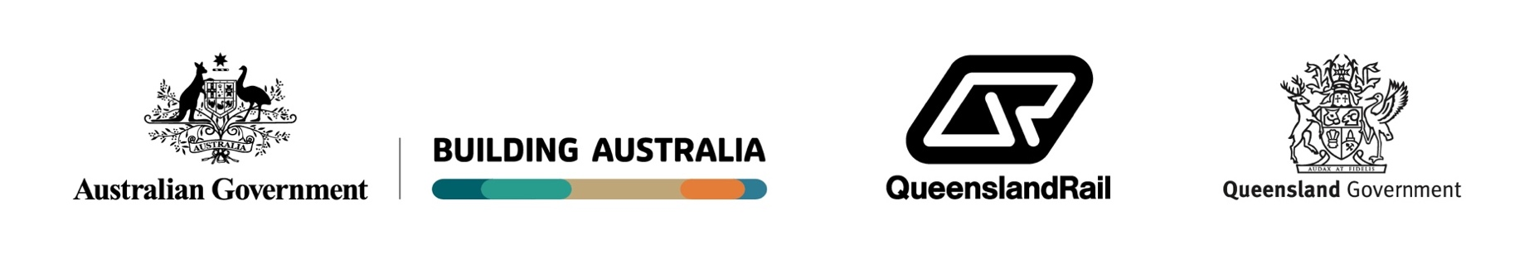

What to expect
 | Increased noise, dust and vibration, with mitigations in place, as required
 | Construction vehicles and equipment, with flashing lights/ reversing alarms, for safety
 | Increased workforce on site and construction traffic on local roads
 | Intermittent odour, when the new sewer line is connected to the existing sewer system
 | Changed traffic and pedestrian conditions, including lane/ shoulder closures, with signage and traffic control in place
 | Access to nearby properties will be maintained unless otherwise agreed.

What’s happening?
In late September 2026, work will start on installing a new sewer line and infrastructure, adjacent to the rail corridor, between David Street and Kingston Road, Kingston (please see map over the page).
Works will continue until late 2026.
On David Street:
Removing existing underground water infrastructure, requiring temporary service interruptions. Impacted properties will be notified in advance.
From David Street to Kingston Road:
Vegetation removal, trenching and under boring works to relocate existing services and install a new sewer line and infrastructure, including manholes and release valves.
On Marshall Street:
Constructing a new sewerage pump station, with security fencing and an access road.
Collin Park Closure
From late September 2026, Collin Park on Collin Court, Kingston will be closed to the public, to enable further works to be undertaken safely for the new sewer line.

Work hours
 | Standard hours: 6.30am to 6.30pm, Monday to Saturday
 | Out of hours: Intermittently 6.30pm to 6.30am, Monday to Sunday
Weather and site conditions permitting.

Key benefits for the community
 | Improved network efficiency
 | Improved accessibility
 | Improved safety

Kingston sewer works

Logan and Gold Coast Faster Rail
 | Works notice | September 2026

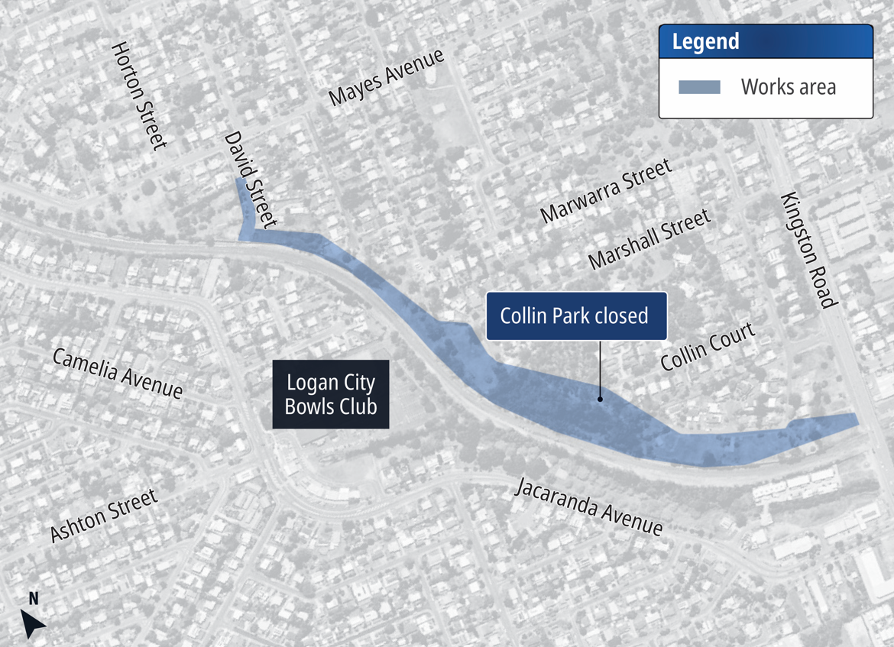

Out-of-hours works
Out-of-hours works may be required along and beside the rail corridor, between Kingston Road and Marshall Street, and on David Street, Kingston, intermittently from 6.30pm to 6.30am, Monday to Sunday as part of sewer construction.
We appreciate your patience during these works. We will continue to keep you updated as works progress.

Kingston sewer works area


Stay up to date
 | Search on tmr.qld.gov.au:  ‘Logan and Gold Coast Faster Rail’
 | Email: lgcrail@activusalliance.com.au
 | Call: 1800 957 066 (all hours)

For information in Gagana Sāmoa, ਪੰਜਾਬੀ, 简体中文, عربي
and தமிழ் or other support services, please contact the
project team on 1800 957 066 (9am – 5pm Monday to Friday).

For more information,
scan the QR code
www.tmr.qld.gov.au/logangoldcoastrail

13 QGOV (13 74 68)
www.tmr.qld.gov.au | www.qld.gov.au

