Works notice
November 2026

Kuraby Open Level Crossing Removal
Services relocations and bridge construction works are continuing.

What’s happening in November?
Underground services installation
New underground utility services will be installed, between Jacob Lane and Warrigal Road:
- open trenching, earthworks and backfilling by excavators and using vibratory rollers
- heavy vehicles transporting material fill
- installing new sewer and water pipes, telecommunications conduits and stormwater drainage
- connecting new services to existing networks
- pumping out from sewer manholes, sometimes out of hours.
Advance notice will be provided about any planned service outages, if required.
Please see map below for locations.
Earthworks and retaining wall construction
Work will commence on constructing the new St Davids Street loop:
- installing precast concrete panels and steel wall reinforcement to construct a retaining wall
- heavy vehicles transporting fill material to site, using access gates along Beenleigh Road
- road works using excavators, graders and vibratory rollers.

Bridge construction works
Works are continuing on the bridge abutments and pier:
- cutting and welding reinforcing steel
- concrete pours, sometimes out of hours
- delivering and installing precast concrete panels
- delivering and compacting fill material, using excavators, graders and vibratory rollers.

Winifred Street upgrade works
Road upgrade works are continuing:
- removing existing road surface and curbing
- excavation to install stormwater drainage
- heavy vehicles transporting fill material
- backfilling, and rebuilding road surface.

Work hours
Standard hours: 6:30am to 6:30pm, Monday to Saturday
Out of hours works: 6:30am to 6:30pm Sunday, and 7pm to 5am Sunday to Thursday

What to expect
- Noise, dust, odour and vibration, with water carts to supress dust as required.
- Vehicle and pedestrian changes, traffic control and signage:
  - Beenleigh Road
  - Jacob Lane
  - St Andrew Street
  - Alpita Street
  - Allbutt Street
  - Strathmore Street
  - Donegal Street
  - Winifred Street
  - Corella Villas
  - Timbertop Grove.
- Heavy/light construction vehicles and equipment with flashing lights and reversing beepers.
- Short term service outages, including water and telecommunications. Impacted residents will be notified in advance.
- Works around Kuraby Square, Kuraby Mosque and Kuraby station with access maintained at all times.
- Qualified subcontractors conducting soil testing and ground treatment, as required.
We appreciate your patience during these works. We will continue to keep you updated as works progress.

Work areas
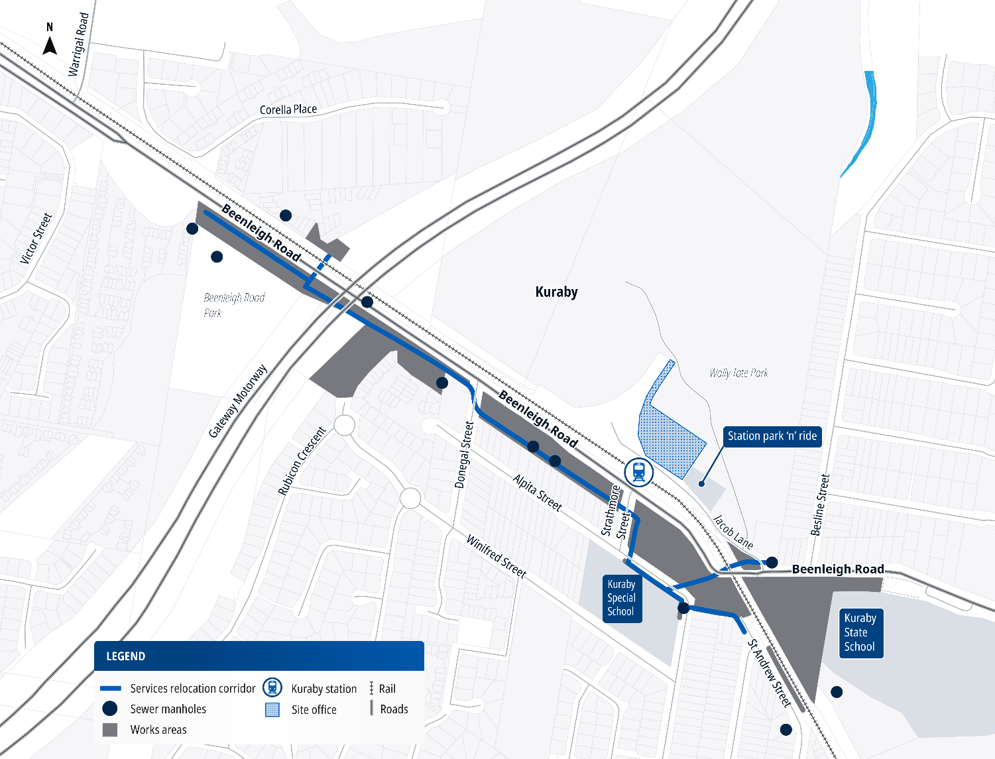

About the project
The Beenleigh Road, Kuraby level crossing is being replaced with a road-over-rail bridge, to improve safety and ease traffic congestion for both road and rail users.
This is the first of five level crossings to be removed as part of the Logan and Gold Coast Faster Rail (LGC) project.
The Kuraby OLCR project is jointly funded by the Australian and Queensland governments on a 50:50 basis.

Contact us
Search on tmr.qld.gov.au: ‘Kuraby level crossing removal’
Email: lgc_olcr@bhjv.com.au
Call: 1800 957 066 (select option 3)
For further information, or if you require translation or support services to access
the documentation, please contact the project team on 1800 957 066 (9am – 5pm Monday to Friday).

For more information, scan the QR code or visit www.yoursay-projects.tmr.qld.gov.au/logan-and-gold-coast-faster-rail/beenleighroadkuraby

13 QGOV (137468)
www.tmr.qld.gov.au | www.qld.gov.au

