Works notice
September 2026

Kuraby Open Level Crossing Removal
Service relocations and bridge construction continue in September 2026.

What’s happening?
Underground services installation
New underground utility services will be installed under Beenleigh Road and the rail line, between St Davids Street and Warrigal Road. Works will include:
- vegetation removal, excavation, material deliveries and concrete works using excavators, compacting equipment, bucket trucks, borer lifts and cranes
- fencing, building laydown pads, and construction access installation
- trenchless drilling, using micro-tunnelling and boring machines.
Please see work area map below for locations.

Services relocations
Relocation of telecommunication and sewer assets will commence between St Andrew Street and Winifred Street. Works will include:
- installing temporary fencing
- material deliveries by heavy vehicles
- open trenching, earthworks and backfilling by excavators
- installing new conduits and cables, and sewer pipes.
Telstra and Optus will provide advance notification of any service interruptions.

Bridge construction works
- Cutting and welding reinforced steel
- Concrete pours, sometimes out of hours
- Precast panel deliveries and installation
- Material fill deliveries and compaction.

Winifred Street upgrade works
Works will continue to upgrade Winifred Street including:
- removing existing road surface and curbing
- excavation and installing stormwater drainage
- backfilling, and rebuilding road surface.

Protective gantry installation
A protective gantry will be installed on the southern pedestrian approach to the level crossing, next to the St Andrew Street work area.

The gantry will make sure safe access is maintained as bridge construction occurs overhead.

Changes to pedestrian detour – St Andrew Street
Pedestrian access from St Andrew Street to the pedestrian level crossing will be detoured via existing paths on Alpita Street, Strathmore Street and Beenleigh Road.
As construction activities increase, these changes are necessary to keep the community and construction team safe.
Please see map below.

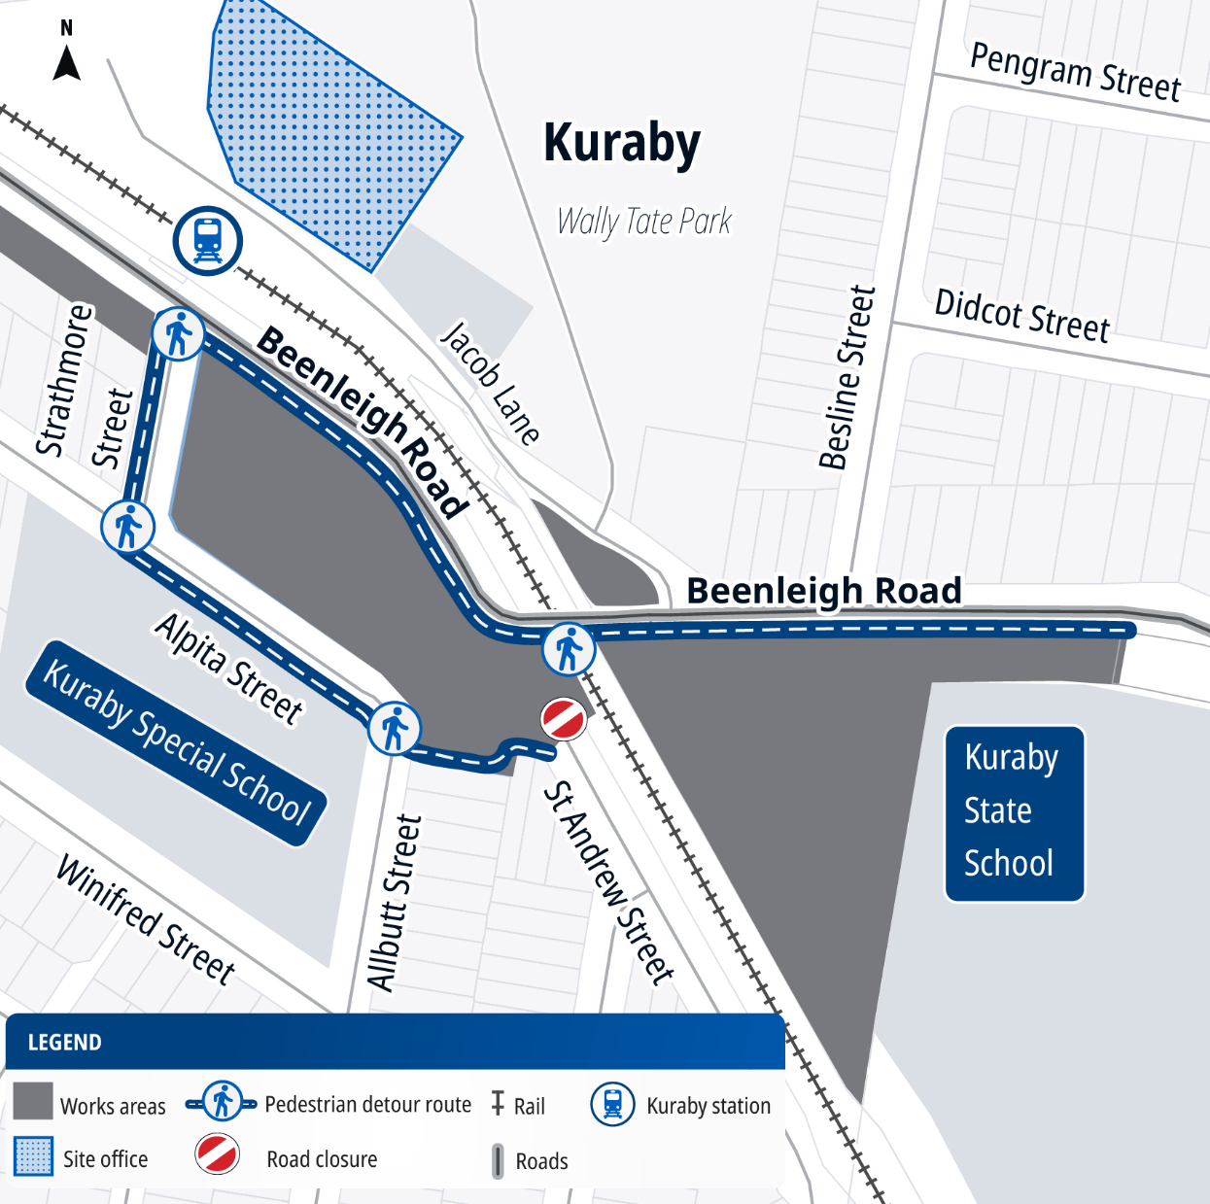

Work hours
Standard hours: 6:30am to 6:30pm, Monday to Saturday
Out of hours works: 6:30am to 6:30pm Sunday, and 7pm to 5am Sunday to Thursday
We appreciate your patience during these works. We will continue to keep you updated as works progress.

What to expect
- Noise, dust, odour and vibration, with water carts to supress dust as required
- Heavy/light construction vehicles with flashing lights and reversing beepers.
- Vehicle and pedestrian changes, with traffic control and signage, on:
  - Beenleigh Road
  - Jacob Lane
  - St Andrew Street
  - Alpita Street
  - Strathmore Street
  - Donegal Street
  - Winifred Street
  - Corella Place
- Temporary parking closures within:
  - Kuraby station park ‘n’ ride
  - Wally Tate Park
  - Jacob Lane
  - St Andrew Street
- Short term service outages, including sewer and telecommunications.
- Qualified fauna spotters/ catchers during vegetation clearing works, as required.
- Works around Kuraby Square, Kuraby Mosque and Kuraby station. Access will be maintained at all times.

Track closures and travel changes on the Beenleigh and Gold Coast lines
From Wednesday 19 September to Monday 5 October 2026, there will be major track closures on the Beenleigh and Gold Coast lines for works on multiple rail projects, including the Logan and Gold Coast Faster Rail project.
Please plan ahead, consider your travel options and allow plenty of travel time.
Download the Translink app, visit translink.com.au or call 13 12 30.

Work areas
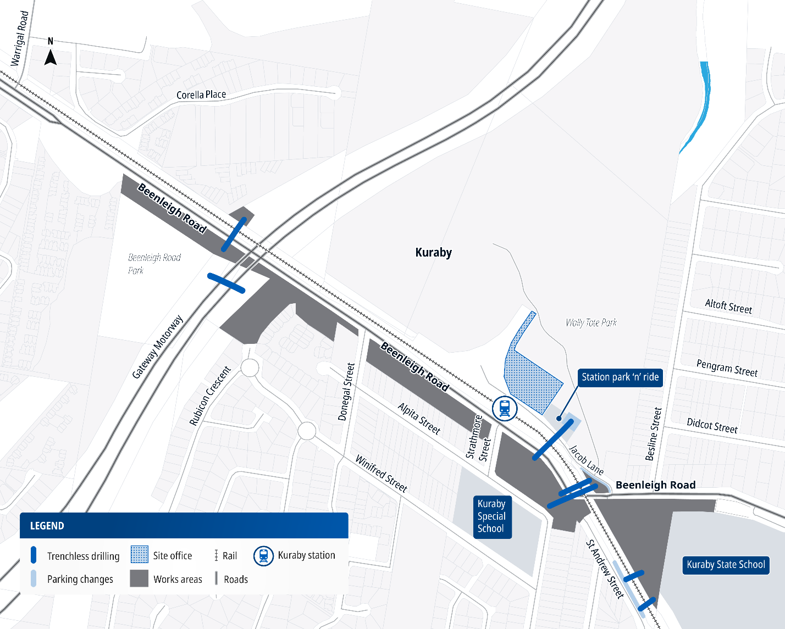

About the project
The Beenleigh Road, Kuraby level crossing is being replaced with a road-over-rail bridge, to improve safety and ease traffic congestion for both road and rail users.
This is the first of five level crossings to be removed as part of the Logan and Gold Coast Faster Rail (LGC) project.
The Kuraby OLCR project is jointly funded by the Australian and Queensland governments on a 50:50 basis.

Contact us
Search on tmr.qld.gov.au: ‘Kuraby level crossing removal’
Email: lgc_olcr@bhjv.com.au
Call: 1800 957 066 (select option 3)
For further information, or if you require translation or support services to access
the documentation, please contact the project team on 1800 957 066 (9am – 5pm Monday to Friday).

For more information, scan the QR code or visit www.yoursay-projects.tmr.qld.gov.au/logan-and-gold-coast-faster-rail/beenleighroadkuraby

13 QGOV (137468)
www.tmr.qld.gov.au | www.qld.gov.au

